Step 1 — Setting Up the Project
First, open your terminal window and create a new project directory:
mkdir ejs-demo
Copy
Then, navigate to the newly created directory:
cd ejs-demo
Copy
At this point, you can initialize a new npm project:
npm init -y
Copy
Next, you will need to install the express package:
npm install express@4.17.1
Copy
Then install the ejs package:
npm install ejs@3.1.6
Copy
At this point, you have a new project ready to use Express and EJS.

Step 1 — Configuring with server.js
With all of the dependencies installed, let’s configure the application to use EJS and set up the routes for the Index page and the About page.
Create a new server.js file and open it with your code editor and add the following lines of code:
server.js
var express = require('express');var app = express();
// set the view engine to ejs
app.set('view engine', 'ejs');
// use res.render to load up an ejs view file
// index page
app.get('/', function(req, res) {
res.render('pages/index');});
// about page
app.get('/about', function(req, res) {
res.render('pages/about');});

app.listen(8080);
console.log('Server is listening on port 8080');
Copy
This code defines the application and listens on port 8080.
This code also sets EJS as the view engine for the Express application using:
`app.set('view engine', 'ejs');`
Copy
Notice how the code sends a view to the user by using res.render(). It is important to note that res.render() will look in a views folder for the view. So you only have to define pages/index since the full path is views/pages/index.
Next, you will create the views using EJS.

Step 2 — Creating the EJS Partials
Like a lot of the applications you build, there will be a lot of code that is reused. These are considered partials. In this example, there will be three partials that will be reused on the Index page and About page: head.ejs, header.ejs, and footer.ejs. Let’s make those files now.
Create a new views directory:
mkdir views
Copy
Then, create a new partials subdirectory:
mkdir views/partials
Copy
In this directory, create a new head.ejs file and open it with your code editor. Add the following lines of code:
views/partials/head.ejs
<meta charset="UTF-8">
<title>EJS Is Fun</title>

<!-- CSS (load bootstrap from a CDN) -->
<link rel="stylesheet" href="https://cdnjs.cloudflare.com/ajax/libs/twitter-bootstrap/4.5.2/css/bootstrap.min.css">
<style>
body { padding-top:50px; }
</style>
This code contains metadata for the head for an HTML document. It also includes Bootstrap styles.
Next, create a new header.ejs file and open it with your code editor. Add the following lines of code:
views/partials/header.ejs
<nav class="navbar navbar-expand-lg navbar-light bg-light">
<a class="navbar-brand" href="/">EJS Is Fun</a>
<ul class="navbar-nav mr-auto">
<li class="nav-item">
<a class="nav-link" href="/">Home</a>
</li>
<li class="nav-item">
<a class="nav-link" href="/about">About</a>
</li>
</ul>
</nav>
This code contains navigation for an HTML document and uses several classes from Bootstrap for styling.
Next, create a new footer.ejs file and open it with your code editor. Add the following lines of code:
views/partials/footer.ejs
<p class="text-center text-muted">&copy; Copyright 2020 The Awesome People</p>
This code contains copyright information and uses several classes from Bootstrap for styling.
Next, you will use these partials in index..ejs and about.ejs.

Step 3 — Adding the EJS Partials to Views
You have three partials defined. Now you can include them in your views.
Use <%- include('RELATIVE/PATH/TO/FILE') %> to embed an EJS partial in another file.
- The hyphen <%- instead of just <% to tell EJS to render raw HTML.
- The path to the partial is relative to the current file.
Then, create a new pages subdirectory:
mkdir views/pages
Copy
In this directory, create a new index.ejs file and open it with your code editor. Add the following lines of code:
views/pages/index.ejs
<!DOCTYPE html>
<html lang="en">
<head>
<%- include('../partials/head'); %>
</head>
<body class="container">

<header>
<%- include('../partials/header'); %>
</header>

<main>
<div class="jumbotron">
<h1>This is great</h1>
<p>Welcome to templating using EJS</p>
</div>
</main>

<footer>
<%- include('../partials/footer'); %>
</footer>

</body>
</html>
Save the changes to this file and then run the application:
node server.js
Copy
If you visit http://localhost:8080/ in a web browser, you can observe the Index page:
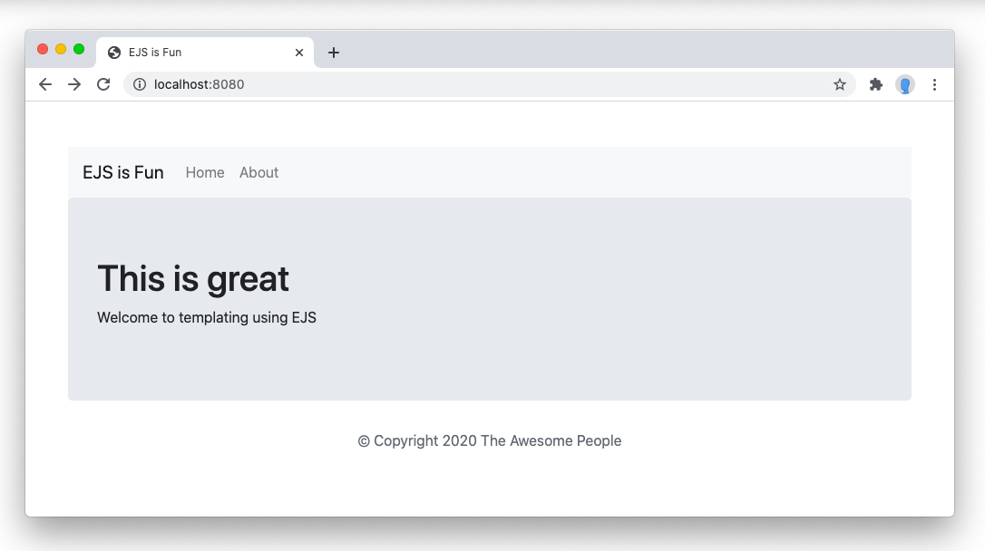
Next, create a new about.ejs file and open it with your code editor. Add the following lines of code:
views/pages/about.ejs
<!DOCTYPE html>
<html lang="en">
<head>
<%- include('../partials/head'); %>
</head>
<body class="container">

<header>
<%- include('../partials/header'); %>
</header>

<main>
<div class="row">
<div class="col-sm-8">
<div class="jumbotron">
<h1>This is great</h1>
<p>Welcome to templating using EJS</p>
</div>
</div>

<div class="col-sm-4">
<div class="well">
<h3>Look I'm A Sidebar!</h3>
</div>
</div>
</div>
</main>

<footer>
<%- include('../partials/footer'); %>
</footer>

</body>
</html>
This code adds a Bootstrap sidebar to demonstrate how partials can be structured to reuse across different templates and pages.
Save the changes to this file and then run the application:
node server.js
Copy
If you visit http://localhost:8080/about in a web browser, you can observe the About page with a sidebar:
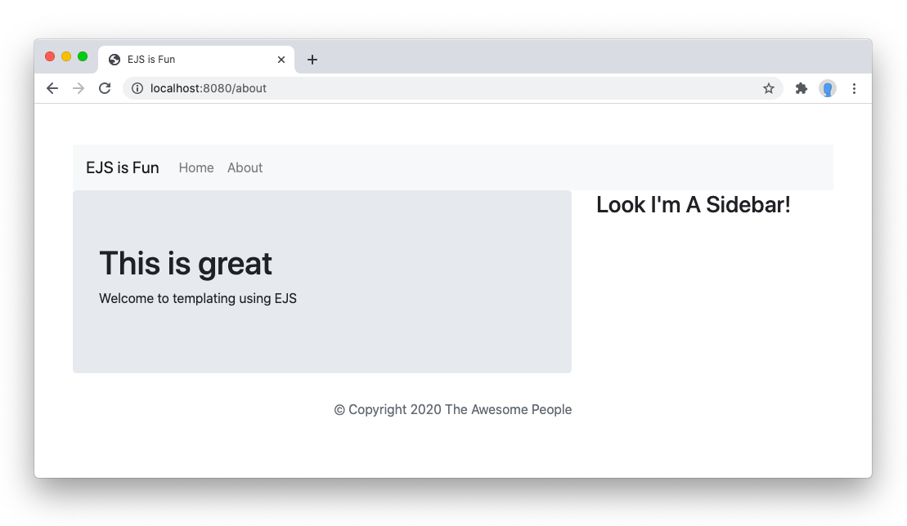

Server.js

var express = require('express');
var app = express();
// body-parser is a module or middleware of node js i.e used to post data from users form on server via body-parser
const bodyParser=require("body-parser");
const path=require('path');
// set the view engine to ejs
app.set('view engine', 'ejs');
app.set('views',path.join(__dirname,'views'));
// used express.static('public') to load css | js | images | fonts
app.use(express.static('public'));
// create a middleware to post data via form on node server
app.use(bodyParser.urlencoded({
extended:true
}));
// use res.render to load up an ejs view file
// index page
app.get('/', function(req, res) {
res.render('pages/index');
});
// about page
app.get('/about', function(req, res) {
res.render('pages/about');
});
app.listen(8080);
console.log('Server is listening on port http://localhost:8080');

Views=>pages=>index.ejs

<!DOCTYPE html>
<html lang="en">
<head>
<%- include('../partials/head'); %>
</head>
<body>
<!-- header -->
<%- include('../partials/header'); %>
<!-- banner -->
<%- include('../partials/banner'); %>
<!-- content -->
<%- include('../pages/content'); %>
<!-- footer -->
<%- include('../partials/footer'); %>

</body>
</html>

Views=>pages->content.ejs

<!--flora content -->
<section id="flora-content">
<!-- how it work -->
<div class="container p-5 mt-5">
<h1 class="text-center">How it Works</h1>
<p class="text-center">sing it can make you sound like you have been <br/> studying english
for a long time. Here’s the challenge</p>
<hr class="w-25 mx-auto">
<div class="row">
<div class="col-md-4 rounded-3 p-3">
<h1><i class="bi bi-house"></i></h1>
<h3>Search Apartment</h3>
<p>Lorem ipsum dolor sit amet, consectetur adipiscing elit. Imperdiet tempus felis vitae.</p>
</div>
<div class="col-md-4 rounded-3 bg-primary p-3 text-white">
<h1><i class="bi bi-house-add"></i></h1>
<h3>Select Apartment</h3>
<p>Lorem ipsum dolor sit amet, consectetur adipiscing elit. Imperdiet tempus felis vitae.</p>
</div>

<div class="col-md-4 rounded-3 p-3">
<h1><i class="bi bi-house-check"></i></h1>
<h3>Confirmed Apartment</h3>
<p>Lorem ipsum dolor sit amet, consectetur adipiscing elit. Imperdiet tempus felis vitae.</p>
</div>
</div>

<!-- most trending properties -->
<h1 class="text-center mt-5">Our most trending properties</h1>
<p class="text-center">sing it can make you sound like you have been <br/> studying english
for a long time. Here’s the challenge</p>
<hr class="w-25 mx-auto">
<div class="row">
<div class="col-md-4">
<div class="card border border-0 p-4">
<img src="/images/property1.png" class="img-fluid">
<h6 class="text-primary">Rs.255000</h6>
<h5 class="text-primary">Luxuraries appartment in Rajkot</h5>
<p><span class="bi bi-bell">3</span>&nbsp;<span class="bi bi-house">0</span>&nbsp;<span class="bi bi-shopping-cart">2</span></p>
<p><span class="bi bi-geo-alt"></span>&nbsp;150 feet ring road Rajkot-360006</p>
</div>
</div>
<div class="col-md-4">
<div class="card border border-0 p-4">
<img src="/images/property2.png" class="img-fluid">
<h6 class="text-primary">Rs.255000</h6>
<h5 class="text-primary">Luxuraries appartment in Rajkot</h5>
<p><span class="bi bi-bell">3</span>&nbsp;<span class="bi bi-house">0</span>&nbsp;<span class="bi bi-shopping-cart">2</span></p>
<p><span class="bi bi-geo-alt"></span>&nbsp;150 feet ring road Rajkot-360006</p>
</div>
</div>

<div class="col-md-4">
<div class="card border border-0 p-4">
<img src="/images/property3.png" class="img-fluid">
<h6 class="text-primary">Rs.255000</h6>
<h5 class="text-primary">Luxuraries appartment in Rajkot</h5>
<p><span class="bi bi-bell">3</span>&nbsp;<span class="bi bi-house">0</span>&nbsp;<span class="bi bi-shopping-cart">2</span></p>
<p><span class="bi bi-geo-alt"></span>&nbsp;150 feet ring road Rajkot-360006</p>
</div>
</div>

<div class="col-md-4 mt-3">
<div class="card border border-0 p-4">
<img src="/images/property4.png" class="img-fluid">
<h6 class="text-primary">Rs.255000</h6>
<h5 class="text-primary">Luxuraries appartment in Rajkot</h5>
<p><span class="bi bi-bell">3</span>&nbsp;<span class="bi bi-house">0</span>&nbsp;<span class="bi bi-shopping-cart">2</span></p>
<p><span class="bi bi-geo-alt"></span>&nbsp;150 feet ring road Rajkot-360006</p>
</div>
</div>

<div class="col-md-4 mt-3">
<div class="card border border-0 p-4">
<img src="/images/property5.png" class="img-fluid">
<h6 class="text-primary">Rs.255000</h6>
<h5 class="text-primary">Luxuraries appartment in Rajkot</h5>
<p><span class="bi bi-bell">3</span>&nbsp;<span class="bi bi-house">0</span>&nbsp;<span class="bi bi-shopping-cart">2</span></p>
<p><span class="bi bi-geo-alt"></span>&nbsp;150 feet ring road Rajkot-360006</p>
</div>
</div>

<div class="col-md-4 mt-3">
<div class="card border border-0 p-4">
<img src="/images/property6.png" class="img-fluid">
<h6 class="text-primary">Rs.255000</h6>
<h5 class="text-primary">Luxuraries appartment in Rajkot</h5>
<p><span class="bi bi-bell">3</span>&nbsp;<span class="bi bi-house">0</span>&nbsp;<span class="bi bi-shopping-cart">2</span></p>
<p><span class="bi bi-geo-alt"></span>&nbsp;150 feet ring road Rajkot-360006</p>
</div>
</div>

</div>
</section>

Views->pages->about.ejs

<!DOCTYPE html>
<html lang="en">
<head>
<%- include('../partials/head'); %>
</head>
<body class="container">

<header>
<%- include('../partials/header'); %>
</header>

<main>
<div class="jumbotron">
<h1>This is great about us pages</h1>
<p>Welcome to templating using EJS</p>
</div>
</main>

<footer>
<%- include('../partials/footer'); %>
</footer>

</body>
</html>

Views=>partials=>head.ejs

<meta charset='utf-8'>
<meta http-equiv='X-UA-Compatible' content='IE=edge'>
<title>Flora Real-Estate | provides brokerage on Flate | Shops | showroom</title>
<meta name='viewport' content='width=device-width, initial-scale=1'>
<!-- bootstrap stylesheet -->
<link href="https://cdn.jsdelivr.net/npm/bootstrap@5.1.3/dist/css/bootstrap.min.css" rel="stylesheet" integrity="sha384-1BmE4kWBq78iYhFldvKuhfTAU6auU8tT94WrHftjDbrCEXSU1oBoqyl2QvZ6jIW3" crossorigin="anonymous">
<link rel="stylesheet" href="https://cdn.jsdelivr.net/npm/bootstrap-icons@1.11.3/font/bootstrap-icons.min.css">
<link rel='stylesheet' type='text/css' media='screen' href='/css/style.css'>
<!-- bootstrap js -->
<script src='/js/main.js'></script>
<script src="https://cdn.jsdelivr.net/npm/@popperjs/core@2.10.2/dist/umd/popper.min.js" integrity="sha384-7+zCNj/IqJ95wo16oMtfsKbZ9ccEh31eOz1HGyDuCQ6wgnyJNSYdrPa03rtR1zdB" crossorigin="anonymous"></script>
<script src="https://cdn.jsdelivr.net/npm/bootstrap@5.1.3/dist/js/bootstrap.min.js" integrity="sha384-QJHtvGhmr9XOIpI6YVutG+2QOK9T+ZnN4kzFN1RtK3zEFEIsxhlmWl5/YESvpZ13" crossorigin="anonymous"></script>

Header.ejs

<!-- flora header section -->
<section id="flora-header" class="fixed-top shadow-sm">
<!-- flora navigations -->
<div class="container p-3">
<nav class="nav navbar navbar-expand-md">
<!-- logo -->
<a href="index.html"><img src="images/logo.png" class="img-fluid"></a>
<!-- toggle button -->
<button type="button" class="btn btn-md btn-white text-dark navbar-toggler" data-bs-toggle="collapse" data-bs-target="#togg"><span class="bi bi-grid"></span></button>
<div class="collapse navbar-collapse" id="togg">
<ul class="navbar-links">
<li><a href="index.html">Home</a></li>
<li><a href="about.html">About</a></li>
<li><a href="service.html">Service</a></li>
<li><a href="property.html">Property</a></li>
<li><a href="contact.html">Contact</a></li>
<li><a href="#" class="active btn btn-lg w-100" data-bs-toggle="modal" data-bs-target="#account">Account <span class="bi bi-person-add"></span></a></li>
</ul>
</div>
</nav>
</div>
</section>

Banner.ejs

<!-- flora banner section -->
<section id="flora-banner">
<div class="container banner-text">
<h1>Discover a place <br/>you will love to live</h1>
<p>Lorem ipsum dolor sit amet, consectetur adipiscing elit.<br/>Imperdiet tempus felis vitae sit est quisque</p>
<p><form>
<div class="input-group w-75 bg-white border border-0 p-3">
<span class="input-group-text border border-0" id="basic-addon1"><i class="bi bi-geo-alt border border-0"></i></span>
<input type="text" class="form-control border border-0" placeholder="Location" aria-label="Location" aria-describedby="basic-addon1">

<span class="input-group-text" id="basic-addon1"><i class="bi bi-dollar"></i></span>
<input type="text" class="form-control border border-0" placeholder="Price" aria-label="Price" aria-describedby="basic-addon1">

<span class="input-group-text" id="basic-addon1"><i class="bi bi-geo-alt"></i></span>
<input type="text" class="form-control border border-0" placeholder="Type Property" aria-label="Location" aria-describedby="basic-addon1">

<button type="button" class="btn btn-md btn-primary text-white bg-primary rounded-5 fs-3"><i class="bi bi-search"></i></button>
</div>
</form></p>

</div>
</section>

Footer.ejs

<p class="text-center text-muted">&copy; Copyright 2024 The Awesome People</p>

Public=>css
Public=>images
Public=>fonts
Public=>js

